Sprint Delivery Plan

|  |  |
| --- | --- |
| Date | 18.November.2022 |
| Team ID | PNT2022TMID46949 |
| Project Name | Classification Of Arrhythmia By Using Deep Learning With 2-D ECG Spectral Image Representation |
| Maximum Mark | 2 Marks |

The Deliverables Of A Sprint Aren't As Predictable As They Are For Other Projects. Sprint participants have produced sketches and drawings, writing, photographs, comic strips, videos and fully codedworking prototypes. The answer is whatever's right to answer the problem.

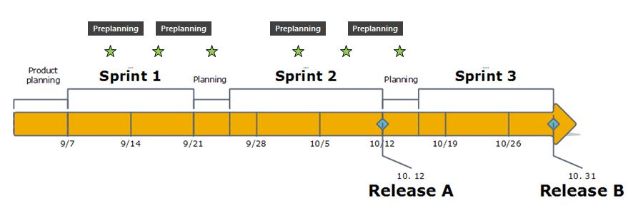

A sprint planning meeting is conducted before the start of a [**sprint**](https://www.visual-paradigm.com/scrum/what-is-sprint-in-scrum/). The purpose of this meeting is to determine the sprint plan and set a [**sprint goal**](https://www.visual-paradigm.com/scrum/write-sprint-goal/).

Sprint planning includes agreeing on the number of backlog items in the sprint that is the responsibility of the development team and as well as to define the goal for the current sprint and [**sprint backlog**](https://www.visual-paradigm.com/scrum/what-is-sprint-backlog-in-scrum/).

During the sprint planning meeting, the [**product owner**](https://www.visual-paradigm.com/scrum/what-is-project-owner-role-in-scrum/) describes the highest priority features to the entire team. They will then discuss which stories the team will do in that sprint. The meeting should be attended by the whole team. If additional expertise on specific backlog items are required, then stakeholders can be also invited. The team may include the refinement sessions as well.